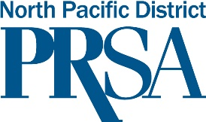

PRSA NORTH PACIFIC DISTRICT APPLICATION FOR STIPEND
UPON AWARD OF ACCREDITATION (APR) BY PUBLIC RELATIONS SOCIETY OF AMERICA

Congratulations on earning your APR!
We are proud to welcome you as a new APR and look forward to your participation as an APR and your many achievements in the years ahead!
To receive your stipend, please provide the information below and send this sheet and confirmation to Michele M. Horaney APR, The APR chair for the North Pacific District, at michelehoraney@thoughtleaderpr.com. Phone is 510.330.9640.

- Your information
Name ____________________________________________________
Address ___________________________________________________
Email _____________________________________________________
Phone ____________________________________________________
Chapter ___________________________________________________

- Confirmation
Please attach the confirmation email or printed letter from PRSA that verifies your receipt of the Accreditation in Public Relations (APR) credential. Thank you!

7.21

